Key Concepts and Highlights

Types of Data and Database Models
Relational Databases (OLTP - Online transactional processing):
  - Use a defined schema with normalized tables to reduce duplication.
  - Data stored in a row-centric manner with tables representing entities (e.g., Users, Offices).
  - Relationships managed through primary keys and foreign keys.
  - Common examples: SQL Server, PostgreSQL, MySQL.
  - Ideal for transactional, high-volume create/read/update/delete operations.
Non-Relational Databases (NoSQL/Not Only SQL):
Types include:
    - Document stores Flexible schema, often self-describing documents like JSON, XML, YAML. Examples – mongodb, couchdb. Used in content management systems, e-commerce catalogs.
    - Key-value stores data stored as key-value pairs, highly scalable via partition keys. Ex – redis. DynamoDB. Used in caching and session management, fast lookups for config data, recommendation engines.
    - Columnar stores data stored column-wise, optimized for compression and efficient analytics; e.g., Apache Cassandra, HBase, Google Bigtable. Used for IoT telemetry, large scale analytical queries.
    - Graph databases (nodes and edges to represent relationships, useful for social networks, e.g., Gremlin API with Cosmos DB, amazon neptune, Neo4j).
  - Unstructured data (binary large objects like images, videos, PDFs without predefined schema). Exampel S3, Azure blob. Used for log archives, media storage, ML datasets.

Azure Database Offerings
Service Type | Description & Key Features
SQL Server in Azure VM (IaaS) | Full responsibility on user for OS, patching, backups, tuning, high availability, disaster recovery.
SQL Server Agent Extension (IAAS +) | 2 modes (both free) – Lightweight (allows to see inventory and can do SQL SKU change) and full mode (for enhanced management, backup, HA and automated patching); agent extension is a free add-on to SQL Server on Azure VM.
Azure SQL Managed Instance (PaaS) | Near 100% compatibility with on-prem SQL Server; deployed inside customer VNet; supports SQL Agent, CLR, cross-db queries/transactions. Multiple Dbs can exist per SQL MI.
Azure SQL Database (PaaS) also called regular SQL server. | Original Paas offering. Fully managed, multi-tenant with private endpoints; many offerings/tiers like single instance/database (fixed resources), elastic pools (shared compute for multiple DB instances allowing better resource utilization), serverless (allows autoscale), and hyperscale (for performance and scale).
Azure Database for PostgreSQL/MySQL (PaaS) | Community editions with Azure enhancements; two deployment models: legacy single server (no future investment) and flexible server (VM-based, supports stop/start, high availability, rich configuration).
Cosmos DB (NoSQL PaaS) | Cloud-native globally distributed multi-model NoSQL database supporting document, key-value, columnar, and graph APIs; configurable consistency levels and multi-region writes.

Database Architectural and Operational Insights
- Relational vs Non-Relational: Decision depends on application needs—transactional workloads favor relational; flexible or highly scalable multi-model scenarios favor NoSQL.
- Managed vs Self-Managed: Azure offers both IaaS (VMs) where users manage DB software and PaaS where Azure manages infrastructure, patching, backups, and scaling.
- Service Tiers and Scalability: Azure SQL MI and Azure SQL Database offer service tiers from basic/general purpose (separate storage for primary instance, some failover downtime when primary instance goes away and new instance need to connect to separated storage) to business critical/premium (local replica of data on secondary instances replicated from primary instance - for fast failover, can have on multiple AZs) and hyperscale (separates compute and storage for massive scale and performance).
- High Availability and Disaster Recovery: Options include synchronous replication for HA and asynchronous for DR, with geo-replication and failover groups.
- Flexible Server for PostgreSQL/MySQL: VM-based, supports burstable instances, stop/start capabilities, optional synchronous HA, and extensive configuration options including connection pooling (PG Bouncer).

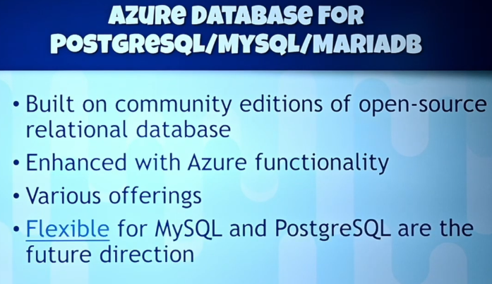
Open Source Based: Offered as Azure PaaS fully managed services.
PostgreSQL – Offerings like Single server (Legacy), Flexible (VM based, can be burstable using b series size, can stop/start, high configuration options), CosmosDB for Postgres (opensource CITUS extension offers distributed tables using partition keys for spreading data over partitions and instances of postgres, improving performance, can run in single node and multinode mode). Great oracle compatibility.
MySQL – Same offerings as postgreSQL
MariaDB – fork of mysql. Only has single mode. Great oracle compatibility.

Cosmos DB Consistency Models and APIs
Consistency Level | Characteristics | Multi-Region Write Support
Strong | Always consistent reads; no multi-region writes allowed; highest latency. | No
Bounded Staleness | Reads lag writes by a configured time or version window. | Yes
Session | Consistent reads within a client session; different sessions may see different data temporarily. | Yes
Consistent Prefix | Reads never see out-of-order writes. | Yes
Eventual | Reads may see out-of-order writes but will eventually be consistent; lowest latency. | Yes
- Cosmos DB supports APIs for SQL (DocumentDB), MongoDB, Cassandra (columnar), Gremlin (graph), and Table (key-value).
- Designed for cloud-native global distribution, partitioning with partition keys, and flexible consistency based on application needs.

Data Warehousing and Analytics with Azure Synapse
- Azure Synapse provides a fully managed PaaS data warehouse optimized for online analytical processing (OLAP).
- Data is often denormalized to optimize query performance and reduce complex joins.
- Integrates compute, storage, SQL querying, and supports external tables directly on data lakes (e.g., Parquet files).
- Supports ETL/ELT workflows via Azure Data Factory, which orchestrates data pipelines but does not transform data itself.
- Supports both batch and streaming data ingestion (e.g., Event Hub, IoT Hub, Stream Analytics).
- Power BI is a common tool for visualization and semantic modeling on top of Synapse.

AI and Machine Learning in Azure
- Artificial Intelligence (AI): Emulates human intelligent behavior, often rule-based.
- Machine Learning (ML): Subset of AI where models learn patterns from data without explicit programming of rules. Uses neural networks to train predictive models.
- ML models enable prediction, classification, language understanding, anomaly detection, and decision making.

Azure AI Services Overview
- Cognitive Services: Pre-built AI APIs for vision (image classification, object detection, semantic segmentation), face detection/analysis, optical character recognition, language (sentiment analysis, entity recognition, translation), speech (speech-to-text, text-to-speech), and anomaly detection.
- Azure OpenAI Service: Integrated GPT models (e.g., GPT-3.5), Codex for code generation, DALL·E 2 for image generation, enabling powerful conversational AI, language understanding, and creativity.
- Other Specialized AI Services: Forms Recognizer, Metrics Advisor, Video Analyzer, Bot Service, Cognitive Search.

Key Insights and Conclusions
- Choice of database technology depends on workload type: OLTP favors relational, OLAP favors data warehousing, and scalable/distributed applications benefit from NoSQL (Cosmos DB).
- Azure provides multiple tiers and deployment options ranging from IaaS VMs to fully managed PaaS services, enabling flexibility and operational ease.
- Cosmos DB’s multi-model and consistency options provide powerful capabilities for globally distributed, highly scalable applications.
- Data pipelines orchestrated by Azure Data Factory enable complex ETL/ELT workflows feeding data warehouses or operational stores.
- AI and machine learning services in Azure cover a broad range of capabilities from vision to language to decision making, with advanced models like GPT integrated for conversational AI.
- Security and compliance features such as encryption, customer-managed keys, and data masking are integral across Azure data services.
- The synergy between data services and AI enables intelligent, scalable, and efficient cloud-native applications.

